MEMORANDUM FOR ALL EXCHANGE STUDENTS
MARAE WEEKEND: August 9 – 11 2019
As you all know, we are to visit a Marae for the above weekend. This notice details much of the information you need for this weekend. It is important that you read these notes carefully and in full

- DIRECTIONS
We will be staying at the following Marae:

Te Tahawai Marae
Edgewater College
32 Edgewater Drive
Pakuranga.
(The Marae is down the driveway on the very right hand side of the school, but we will meet out in the car park area. Parking may be difficult to find on Friday)

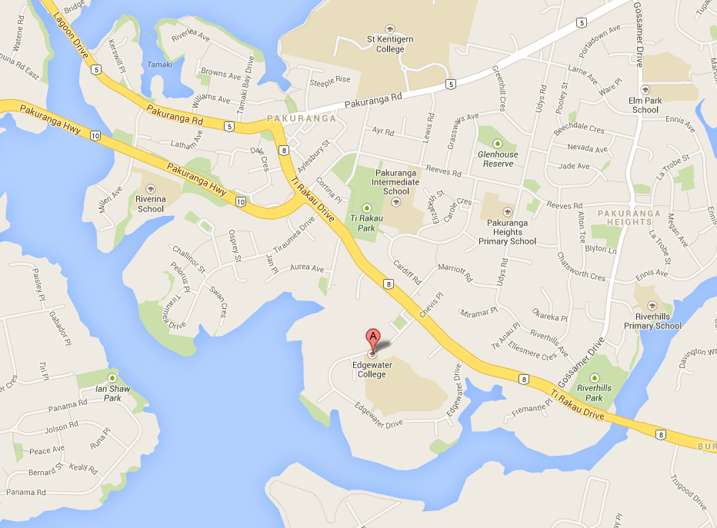

The purpose of the weekend is to provide:
- a Maori cultural experience
- Orientation information about an exchange and how to succeed
- the opportunity for inbound and outbound students to meet each other
- the opportunity for outbound students to talk to inbound students about their country and share perspectives on an exchange

While inbounders may find some of the Rotary sessions duplicate what has already been covered prior to your departure, we see value in your inclusion in these sessions as you can provide additional comment and advice for the outbound students

- ARRIVAL & WELCOME
Students must arrive at 1:00 pm SHARP on Friday 9 August and assemble in the school car park at the right hand side near the Marae. We will then be welcomed in traditional fashion onto the Marae by marae members. Please wait outside the entrance gate until we have all assembled and you have been briefed about marae protocols.

- DRESS
For the arrival and welcome onto the Marae, we should be well dressed. That is, no jeans or jandals and ladies to wear a skirt (to or below the knee) with thick stockings and not jeans /trousers. Inbounds must wear Rotary blazers for the Marae welcomes and farewell. This same dress code applies for Sunday
For the remainder of the weekend casual clothing is suitable – please be respectful of the marae and dress accordingly.

- CLOTHING & EQUIPMENT
You will need to bring the following:

  - Sleeping bag or blankets
  - Pillow & Pillow Case
  - 2 Towels
  - Toiletries (including soap)
  - Shoes suitable for easy removal (Not to be worn in the meeting house!)
  - Slippers for wear ONLY in the meeting house (optional) - Socks are suitable
  - Casual clothing
  - Warm jersey

Please note that on a Marae the sleeping arrangements are communal, so sensible nightwear is required. Note also that the meeting house can be cold

MOBILE PHONES ARE NOT TO BE USED DURING THE WEEKEND

- TRANSPORT
Transport to and from the Marae is the responsibility of each student. Contact Tracey or John if you have any problems.

- POWHIRI
We will be welcomed on to the marae with a formal Powhiri.

As part of the Powhiri you will sing a waiata. We will sing Po Kare Kare Ana. (The lyrics are at the end of this memo). There are youtube links on our youth exchange website that you can watch to learn the tune and pronunciation. Be well prepared and able to sing loudly and confidently. This is a very important for the powhiri.

http://www.youthexchange.org.nz/index.php/meet-our-students/useful-information/

You will probably be asked to introduce yourself in a couple of sentences, so you should try to do this in a traditional Maori way and trace your genealogy. You might say something like this: My name is… and I am being hosted in Auckland by the Rotary club of… and I come from …[town and country you were born in] and my family come from …[where your parents and grandparents etc come from].

This will be followed by a brief overview of Maori culture and traditions. Questions you might ask are:
- What is “Mokopuna”
- What do roof beams in the Wharenui symbolise
- Why do some of the carved characters have long tongues
- What are the woven panels made from
- What is “PaePae”
- When did the Maori come to NZ? Where From? How did they get here?
- What and where are the different Maori tribes
- How did Maori live? What was their day to day life like? What did they eat?
- MAORI CULTURE
"What is a Marae?" and "Maori language". It is important you read these thoroughly prior to your arrival, because there are many aspects of Marae living we need to understand. We are guests of the people and the Marae is full of cultural significance. So, please be careful to respect their protocols and values at all times. Many of these are rather different and you must accept this as part of the reason for spending this weekend on a Marae.

MARAE PROTOCOLS:
- Food must not be bought onto the Marae through the front gate. Use the side access to the rear doors
- No shoes in the meeting house
- No food or drink (including water) in the meeting house
- No sitting on tables or pillows
- Don’t step over people’s feet
- Don’t step over the head of females
- Females don’t place feet on man’s upper body

Also
- All students are to take part in all activities
- You are expected to share in the work on the marae. (meal serving, cleaning etc.)
- Please enter into the spirit of the weekend and do your best to engage and enjoy different cultural perspectives and practices.

- WEEKEND PROGRAM:
The weekend program is VERY full and we will need you to work closely with us to ensure we stay on time and move quickly and efficiently from one session to the next. The housekeeping duties need to be carried out on time and efficiently. It will also be important that you wake up on time and get ready quickly especially as shower facilities are limited. We will start Saturday with 6:45 wake up and Sunday with 6:30 wake up. Please also comply with lights out and NO TALKING – Please respect other student’s entitlement to sleep
- PRESENTATIONS
Outbound Students
Please come prepared to give 10 minutes of your presentation. You will receive feedback on your presentation and they must be of an acceptable standard or a repeat presentation will be scheduled. Bring your powerpoint on a USB – windows compatible.

Inbound Students
You will be given the opportunity to make a 7 - 10 minute speech (with PowerPoint) about you & your country. Focus on that part of your presentation that is about you and your family and your lifestyle and school. Please bring your Power Point presentation (on a USB – windows compatible) and any other presentation aids you wish to use. We will provide a laptop and projector. Please practice your presentation beforehand and ensure it is NO MORE than 10 minutes duration.
Send a copy of your speech notes to Tracey ahead of the weekend.

- COST
The cost of the weekend is $425 (GST inclusive) per student.
Inbound Students: your Host Rotary Club will pay this cost, and they have will be invoiced by the RYE committee.

- OUTBOUND REMINDERS:
Visiting Cards:
We will have business cards printed for you. We will take a portrait photo during the weekend.

- OUTBOUND PARENTS:
Parents of Outbound students are to be welcomed on to the Marae on Sunday at 9:30 am (assemble outside the gate no later than 9.15 a.m. so you can be briefed on Marae protocol). You will be called on to the Marae and welcomed by the students. As part of the powhiri you will sing a waiata. We enclose the lyrics for Po Kare Kare Ana. Please note the dress code above.

Attendance by at least one Parent is compulsory as there will be a full briefing on travel, visa, and insurance matters

- INBOUND HOST PARENTS & COUNSELLORS:
Inbound students, please note that your host family and counsellor are very welcome to come and see the cultural performance. Arrive at 9:15 a.m. to be part of the powhiri when we will sing a waiata. We enclose the lyrics for Po Kare Kare Ana. Please note the dress code above

While the outbound students are briefed on travel arrangements, inbound students will be briefed on the South Island trip. If attending please RSVP so we can make appropriate bookings.

- FINISH TIME:
The weekend will finish at about 2:00 pm on Sunday
- RSVP
Please before 21 September, confirm attendance
  - Inbound students for the full weekend
  - Inbound Student Host families and counsellors for Sunday
  - Outbound students for the full weekend
  - Outbound student parents/family for Sunday
- WAIATA:
Po Kare Kare

Po kare kare ana
No wai o Waiapu
Whiti atu Koe hine
Marino ana e

E hine e
hoki mai ra
Ka mate ahau
i te aroha e

If you have any queries please contact John, Tracey, or Robyn

